**Objective**: Learning about views and understand how views enhance security of database.

**What is view?** : In a database management system, a view is a way of portraying information in the database. This can be done by arranging the data items in a specific order, by highlighting certain items, or by showing only certain items.

**Why view is needed?** : After a table is created and populated with data, it may become necessary to prevent all users from accessing all columns of a table for data security reasons. To do this view is needed.

**Creating a view:**

**SQL syntax:**

CREATE VIEW <view_name> AS SELECT <column_name1>,<column_name2> FROM <table_name> WHERE <condition>;

Ex: CREATE VIEW stdView AS SELECT id,name,age FROM student WHERE age=23;

**Selecting data from a view:**

**SQL syntax:**

SELECT <column_name1>, <column_name2> FROM <view_name>;

Ex: SELECT * FROM stdView;

**Output:**

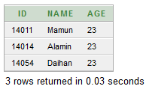

**Renaming the column in a view:**

**SQL syntax:**

CREATE VIEW <view_name> AS SELECT <column_name1> "new_column_name1", <column_name2> "new_column_name2" FROM <table_name> WHERE <condition>;

**Ex:** CREATE VIEW renameView AS SELECT id "indetity", name "studentName", age "studentAge" FROM student WHERE age=23;

**Output:**

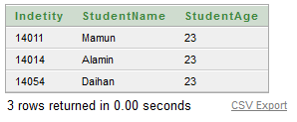

**Updatable views:** View on which data manipulation can be done are called updatable view.

For a view to be updatable, it should meet the following criteria.

1. Views defined from single table.
2. If the user wants to insert records with the help of a view, then the PRIMARY KEY columns and all the NOT NULL columns must be included in the view.
3. The user can update, delete records with the help of a view even if the PRIMARY KEY column and NOT ULL columns are excluded for the view definition.

**If PRIMARY KEY and NOT NULL attribute is not included in view:**

1. Insert operation will not be allowed.
2. Delete row will affect master table.

**SQL example:**

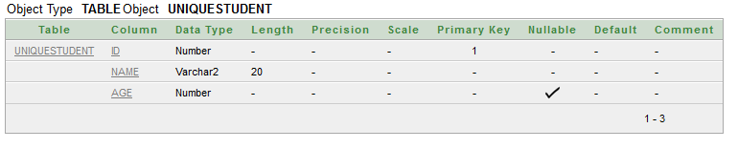

CREATE VIEW nonUpdatableView AS SELECT age FROM uniqueStudent;

INSERT INTO nonUpdatableView VALUES (23);

This SQL will create this error. Because PRIMARY KEY and NOT NULL attribute name is not included in the nonUpdatableView view.



**The nonUpdatableView view and uniqueStudent table ar as follow:**

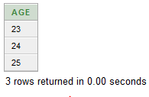 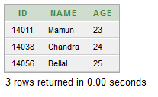

After deleting from nonUpdatbleView (**DELETE FROM nonUpdatableView WHERE age=25**) master table uniqueStudent will be affected.

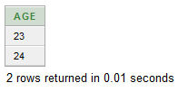 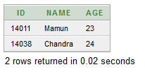

**View defined from multiple table:** Insert, Update, delete operation is not allowed.

Ex:

CREATE VIEW multipleTableView AS SELECT name,age,address FROM studentinfo,uniqueStudent WHERE studentinfo.id=uniqueStudent.id;

**Output:**

